Darryl Green

CIS 2353

Winter 2018

Baugh

TestingSort results:

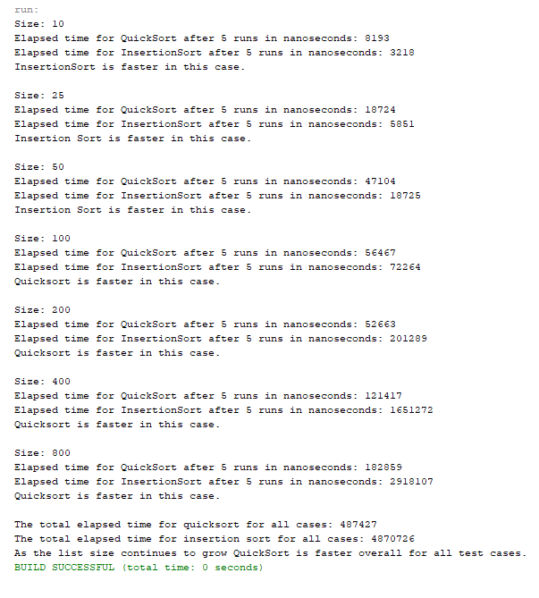

The reason we get the results that are shown above is because as the size of the array increased from 50 to 100, 200, 400, 800, etc. it became more efficient and faster to utilize the QuickSort method versus

InsertionSort which works better on smaller number sets such as 10, 25, 50, 100, etc. before reaching a set of numbers greater than 100.

As shown below in the second set of outputs this time Set 100 ran faster with the InsertionSort method. What I think is happening here is that 100 will at times run better with InsertionSort and others with QuickSort because it is just small enough that one method will at time run better than the other. Though, once we start using integer sets greater than 100 it becomes consistently apparent that QuickSort is the more efficient sorting method to use when working with such large number sets such as 200, 400, 800 etc.

